Project Development Phase
Model Performance Test
Date | 01 September 2026
Team ID | Individual Project
Project Name | Software Installation Request Automation in ServiceNow Using Service Catalog and Workflows
Maximum Marks | ________________
Model Performance Testing:
Project team shall fill the following information in model performance testing template.
S.No. | Parameter | Values | Screenshot
1 | Model Summary | ServiceNow automation setup for software installation request management using Service Catalog, variables, workflows, approval, task automation, tables, Business Rules, notifications, SLA monitoring, and Update Sets. | 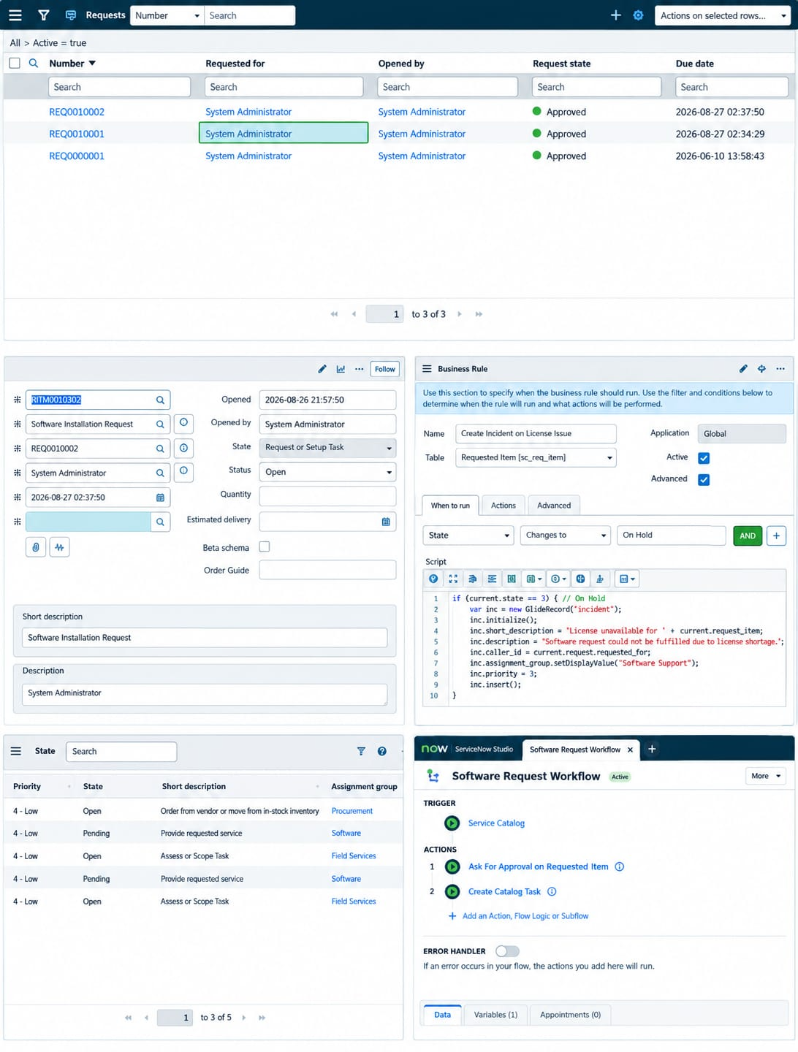
2 | Accuracy | Not specified in the project document. | ______________________________________________________________  ______________________________________________________________
3 | Confidence Score (Only Yolo Projects) | Not applicable to this ServiceNow project. | ______________________________________________________________  ______________________________________________________________

